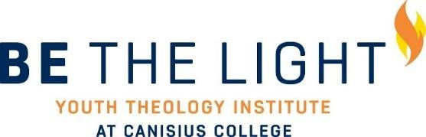

We are looking for creative and diverse student leaders to facilitate the Be the Light Institute (BTLI) this summer. The Be the Light Youth Theology Institute at Canisius will consist of a seven-day residential experience with up to 25 high school students during the summer. The purpose of the institute is to provide high school youth with opportunities to explore their call to the faith that does justice both here in Buffalo and in their home community.

A typical day in the Institute will consist of: morning prayer, an immersion experience in the Buffalo community, an academic session on Catholic theology/Ignatian principles, a workshop co-facilitated by student leaders, an evening reflection, and an activity. Student leaders will live on campus with the BTLI participants, lead daily reflections, and assist with program facilitation.

The Be the Light Youth Theology Institute is made possible by a generous grant from the Lilly Endowment.

Qualifications:
-Must be a current Canisius student (first year through senior)
-Comfortable leading discussions and reflections and talking about one's own relationship with God
-Excellent communication skills
-Can work well with others and looking for new opportunities to develop leadership skills
-Willingness to engage with and experience Institute programming, including academics, immersions, and workshops

Leaders must be available for the following dates:
-Leaders Retreat (February 7-9)
-2-3 Spring Semester Training Dates (TBD)
-Institute (July 18-26)

Timeline for Application:
-Applications due to Campus Ministry (OM 207) by 5pm on November 15
-Interviews: Please sign up for an interview time on Christina Bakos' door (OM213)
-Decisions will be released December 13

Compensation
Room and board during the Institute week
$500 stipend

Questions
Please contact Steve Chanderbhan at chanders@cansius.edu or Christina Bakos at bakos1@canisius.edu for more information.

Name:
Major(s)/Minor(s):
Class Year:
Hometown:
Current G.P.A.:
T-Shirt Size:
Cell Phone:
Email:
Religious Affiliation:

- What about the Be the Light Institute (BTLI) most interests you? Please include why you chose to apply.

- Based on what you know about Be the Light, where do you feel you’ll best be able to apply your strengths?

- What experience do you have with personal and/or group reflection? If none, what skills do you feel you’ll be able apply to this component of the week?

- Where will you be challenged during Be the Light?

- How comfortable are you with faith sharing and leading faith sharing?

- What does “justice” mean to you?

- How have Canisius’ Jesuit values impacted your college experience?

